**Project Proposal on**

**BULL’S CLUB SWIMMING POOL MANAGEMENT SYSTEM**



**Saugat Subedi**

**00174635**

**Computing Project**

**Level 5 Diploma in Computing**

**Softwarica College of IT & E-Commerce**

**Kathmandu, Nepal**

**Submitted to: Sudeep Lal Bajimaya**

**9th April, 2019**

Table of Contents

**1.** **Introduction** 2

1.1 Introduction of project 2

1.2 Background of project 2

1.3 Problem statement 2

1.4 Description of project 2

1.5 Feature of project 3

1.6 Overview of project 3

**2.** **Scope of the project** 3

2.1 Scope 3

2.2 Limitations 4

2.3 Aims 4

2.4 Objective 4

2.5 Overview of scope 4

**3.** **Developmenmt Methodology** 5

3.1 Description of the methodology chosen 5

3.2 Design pattern 6

*3.3* Architecture 7

**4.** **Project Planning** 8

4.1 WBS (Work Breakdown Structure) 8

4.2 Milestones 10

4.3 Gantt Chart 11

**5.** **Risk Management** 13

**6.** **Configuration Management** 15

**7.** **Conclusion** 16

**8.** **Reference and Bibilography** 16

# **Introduction**

## Introduction of project

This is the project of Bull’s Club Swimming Pool. The Bull’s club is in Nakhu which is loacted at Bhainsepati, Lalitpur.This club is unique blend of cultural and modern lifestyle complete with the latest health club service. It offers sports and enjoyment facilities along with great good well-furnished rooms. Not too close to the bustle of the city, yet not too far away. It is the perfect palce to visit for a quick morning swim,enjoyment activities, to enjoy a perfect swimming afternoon away from work and spend a relaxed weekend.

## Background of project

Like other in countries, Nepalese people has been interested as well as attracted to the swiiming . Nowadays swimming is being good business in nepal. As it is hard to go to every palce to find the suitable and quality swimming pool that you want for different purpose. The project will authorized customer to view the bull’s club swimming pool and they can get various information about it and also they can register their name and fill the membership of club and they can booked the ticket any time from any palce through the online which makes customer easy. The people will get in touch easily with Bull’s club through the help of this project.

## Problem statement

The main problem is to get information about Bull’s club swimming pool. Mostly people donot know about this swimming pool. And also people can face various problem while searching for suitable palce for swimming. The solution for this problem is web based system for searching a place for swim and through the help of web based syetem customer can get the detailed information about Bull’s club swimming pool.

## Description of project

I have choose to buld a web based system where customer can easily know about Bull’s club swimming pool. This Bull’s club project maily focused in swimming pool but beside swimming pool this project will include some other sport activities like Badmintion,Gym,Basketball,Futsal,and Indoor circket which was performed in the club. This project is particularly developed for those customer who insecure their important time to find sutiable swimming pool. For this project, a simple user friendly GUI has been created which is easy for customer as well as for staff to operate by using PHP language. All the client information is kept in the database.

I have been choose XAMPP for database and PHP language.

## 1.5 Feature of project

* Information concerning about Bull’s club swimming pool detail and service provide are recorded.
* Easy to understand GUI which helps simple navigation for customer as well as for staff.
* All the detailed information about club is viewed by client.
* Customer can contact the club through the phone number and e-mail about any question any regarding problem.
* Customer can booked the swimming pool beside swimming pool they can also book nay sport activities which was listed in the booking form.
* Customer can login in form for membership of the club.

## 1.6 Overview of project

For this project, a simple user friendly GUI has been created which is easy for customer as well as for staff to operate. All the client information is kept in the database. As in the contain of the nepal many swimming pool don’t have their web based system. So this project helps people to get to know about swimming pool and also allows to find suitable swimming pool without any difficulties. And also from website people can view the swimming pool and they can booked swimming pool for various activities through website as well as they can register and login their name for membership of club through website.

# **Scope of the project**

## Scope

Scope is required for the intial step for building up an project aims, choose the required assets, features, distribute the time needed to uplift the standrd of the Bull’s club swimming pool which will meet need of the customer and on given spending plan of budget.

## Limitations

* Poor web link can prompt unaccess to the website.
* Client can’t contact, see or check the object personally and by rather keep confidence in photograph and the determination given.
* Quality of good service is not guranted totally.
* Client did not get swimming experience by the project and arrange the cost.
* Client can’t see live swimming game information and articles about it.

## Aims

***Some of aim of my project are mentioned below:-***

* The main aim of our project to develop and design the web-based system by which customer can know about Bull’s club swiiming pool.
* To develop web-based system by which customer can find our swimming pool location from any place at any time and also customer can be membership of our club through web based sytem.
* To develop web-based sytem which is cost effective, time reduce and user friendly GUI.

## Objective

***Some of objective of my project are mentioned below:-***

* Various maintenance must be done to avoid or reduce the bug and errors.
* To distinguish the necessities, demands, and do examination and produce report about it.
* Documenting all the modelling pattern, development and design information.
* To perform practicality examination.
* To development and design process I am using various naming conventing and code design pattern.

## Overview of scope

For this project development various aims, needed resources, various project related feature as well as certain time and limited budget are allocated in order to develop this project. And from this project customer can view Bull’s club swimming pool as much as they like and get various facility through this project which definitely save their time and money.

# **Developmenmt Methodology**

## Description of the methodology chosen

***Waterfall Model:***

Waterfall approach which is otherwise called Liner sequential life cycle model in which the procedure is continuing move in the descending stage starting with one stage then onto the next is called waterfall. The waterfall model was the main process model to be presented. In waterfall model each stage must be finished before the following stage can start and there is no covering in the stages. I have prefer to choose waterfall methodology because:

* It is easy to understand as well as easy to use in the project development.
* Advance milestone, can be caught effectively for example we can recognized where is our project advancement running.
* Customer isn’t required for connection after the demenad stage expect in analysis, agreement and gatherings
* Designing and planning are increasingly open as customer and create admit the necessity and programming to be distributed. (Anon., 2019)

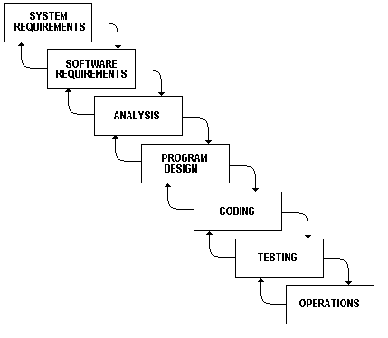

***Fig 3.1.1 Waterfall Model***

## Design pattern

***MVC pattern:***

It is of made three part model view and controller. The model view controller configuration design determines that an application comprise of an information display, introduction data, and control data. The example necessitates that each of these be isolated into various items. MVC is a greater amount of a building design, however not for complete application. MVC generally identifies with the UI/connection layer of an application (Kumar, 2018). The class chart of the code is shown below:

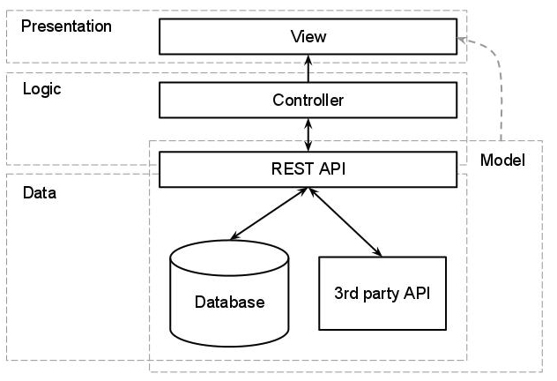

***Fig3.2.1 MVC Pattern***

## Architecture

***Client Server architecture*:**

Client server architecture,architecture of a PC organize in which numerous customers (remote processors) demand and get administration from an incorporated server (have PC). Customer PCs give an interface to enable a PC client to demand administrations of the server and to show the outcomes the server returns. Servers trust that solicitations will touch base from customers and after that react to them. (Britannica, 2019)

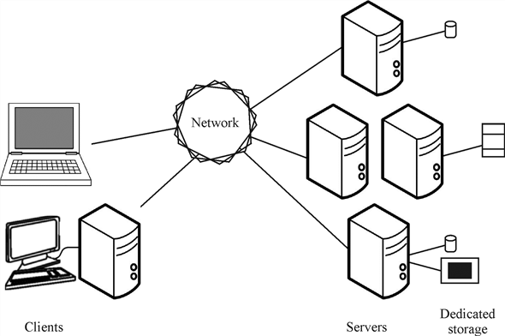

***Fig 3.3.1* *Client server architecture***

# **Project Planning**

## WBS (Work Breakdown Structure)

A WBS structure is a key project deliverable that composes the collaboration into reasonable sections.The Project Management Body of Knowledge characterizes the work breakdown structure as a "deliverable arranged various leveled decay of the work to be executed by the undertaking group." The work breakdown structure outwardly characterizes the extension into sensible lumps that a venture group can comprehend, as each dimension of the work breakdown structure gives further definition and detail. With the assistance of WBS timetable of task, hazard and cost of project to be happened can be distinguished. Work breakdown structure helps to oragized as well as defined the various work of project and it helps to reduce and also helps to manage various complex task of the project. And also each and every step of project will be completed on time. (Anon., 2019)

The works Breakdown Structure of Bull’s Club Swimming Pool Management System of project is as shown below:

**Bull’s Club Swimming Pool MA;lmdlkaslkdncdnlkasndlknslkdnMkndnskdnkslnklsnlkcnslkMManagement**

**proposal**

**Implementation**

**Analysis and requirement**

**Design**

**Other Project Issues**

**Testing**

Scoping

Coding

Unit Testing

Requirement

Installation

an

Structural Model

Planning

Final Report

Use Case

Database Model

Integration Testing

Controlling & Monitoring

Brainstormingg

Maintained if needed

Behavioural Model

Architecture case

***Fig 4.1.1 Work breakdown Structure of the project***

|  |  |  |
| --- | --- | --- |
| **WBS** | **Task Name** | **Days** |
| **1** | **Sport Shop Management System** | **107** |
| **2** | **Proposal** | **16** |
| **2** | **Analysis** | **28** |
| 2.1 | Requirement | 8 |
| 2.2 | Brainstorming | 8 |
| 2.3 | Use case | 8 |
| 2.4 | Architecture | 4 |
| **3** | **Design** | **25** |
| 3.1 | Structural Model | 5 |
| 3.2 | Database Design | 10 |
| 3.3 | Behavioural Design | 10 |
| **4** | **Implementation** | **20** |
| 4.1 | Coding | 20 |
| **5** | **Testing** | **7** |
| 5.1 | Unit Testing | 3 |
| 5.2 | Integration Testing | 4 |
| **6** | **Other Project Isuues** | **11** |
| 6.1 | Installation | 2 |
| 6.2 | Final Report | 4 |
| 6.3 | Maintained if needed | 5 |

***Fig4.1.2 Work Breakdown Structure Time Estimation***

## Milestones

The five major milestones of Bull’s Club Swimming pool Project is shown below in the table:

|  |  |
| --- | --- |
| **Milestones** | **Dates** |
| Project Proposal | 9th April 2019 |
| Analysis | 7th May 2019 |
| Design | 1st June 2019 |
| Implementation | 21th June 2019 |
| Testing | 28th June 2019 |
| Other Project Isuues | 9th July 2019 |

***4.2.1 Milestone of Project***

## 4.3 Gantt Chart

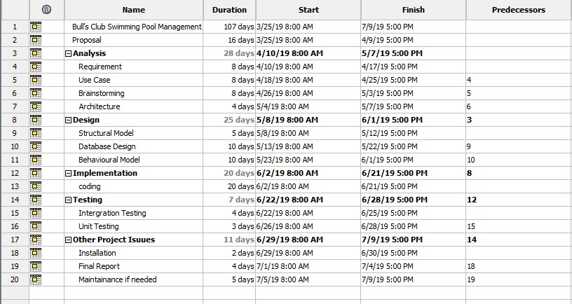

***Fig 4.3.1 Sceduling of the project***

In the above Sceduling figure, all the task as well as project various name are listed in above figure. And various task date and time is estimated in the schedule . 25th march, 2019 is the start date of project and 9th july, 2019 is the end date of the project. So every task of the project should be completed in the estimated of the date.

***Grantt Chart of Spreadsheet:***

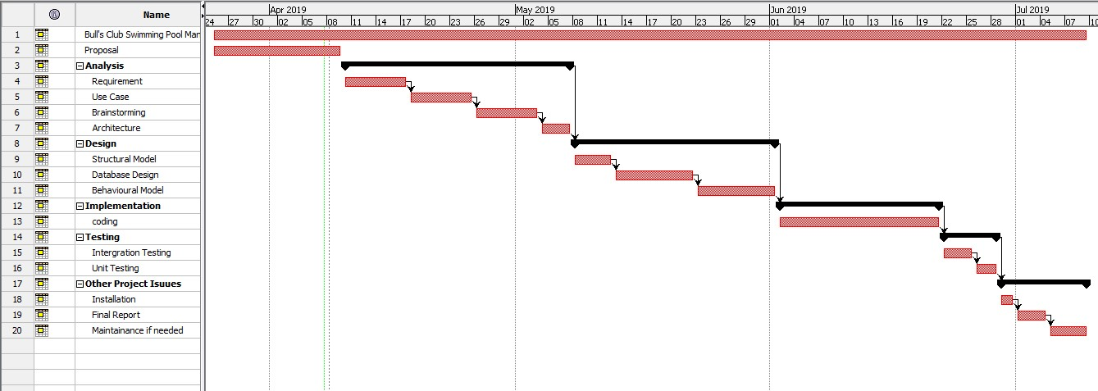

***Fig 4.3.2 Gantt Chart of the project***

# **Risk Management**

Risk management is the way toward recognizing, evaluating and controlling threats to an association's capital and income. These risk, or threats, could originate from a wide assortment of sources, including money related vulnerability, lawful liabilities, vital administration mistakes, natural disasters and casuality.In the risk management various step are taken for the process of risk management following step are listed below:-

* Risk Identification.
* Risk analysis.
* Risk monitoring.
* Treat the Risk.
* Risk evaluation and assessement. (Rouse, 2009)

The table of value for consequence and for the likelihood as shown in table below:-

|  |  |
| --- | --- |
| **Likelihood** | **Value** |
| Low | 1 |
| Medium | 2 |
| High | 3 |

***Fig 5.1: Risk Likelihood with values***

|  |  |
| --- | --- |
| **Consequences** | **Value** |
| Very Low | 1 |
| Low | 2 |
| Medium | 3 |
| High | 4 |
| Very high | 5 |

***Fig 5.2: Risk Consequences with Values***

***Formula of Imapact Risk:***

***Impact=Likelihood x Consequences***

|  |  |  |  |  |  |
| --- | --- | --- | --- | --- | --- |
| **S.N** | **Risk** | **Likelihood** | **Consequence** | **Impact** | **Action** |
| 1 | Hard disk crash | 2 | 5 | 10 | Data backup is required and data should stored in gogle drive or in GitHub for backup. |
| 2 | Unauthorized access | 3 | 5 | 15 | Various data and information should be encrypted and implementation of firewall and strong psssword in various devices. |
| 3 | Possibility of illness | 2 | 3 | 6 | Healthy lifestyle should be maintain properly. |
| 4 | Load shedding problem | 2 | 4 | 8 | Power supply backup should be kept . |
| 5 | Natural diasasters | 1 | 4 | 4 | Develop a security plan and policy for recovery of data |
| 6 | Loss of data | 2 | 3 | 6 | Backup of data is required which helps to recover the data in the future. |
| 7 | Software and hardware failure. | 2 | 4 | 8 | Analysis of the cost should be done and backup of data is required again. |

***Fig 5.3 Risk Management Table***

# **Configuration Management**

The procedure of efficiently dealing with changes to a framework such that it keeps up honesty after some time is known Configuration management. Configuration management is a control which is utilized to deal with the progressions present to its items. design the board helps in recognizing singular components and setup following changes, reinforcement and form control.

***Feature:***

* It gets to control to the envelope for security reason
* It gives work process of the project and make simple for inspect, certify and recognize changes..
* Also help to follow the advancement.

We choose the particular time/date and start to sort out the code, and spot every one of the pieces task into one catalog additionally be called control framework. Presently, with exertion to this standard, advance on project can be made and make sure that the progressions are archived and oversaw appropriately It guarantees the records are not copied, stop error and alter (Lotz, 2019)

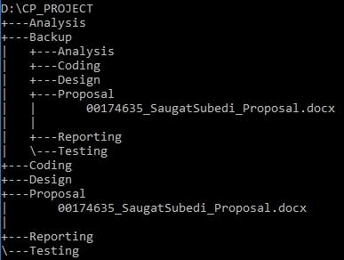

***Fig 6.1 Directory structure of project***

# **Conclusion**

So, I propose this “swimming pool management system” for Bull’s Club for the advertisement as well to provide information about Bull’s Club swimming pool which will help customer to know about Bull’s Club and aslo this project will make easy to customer for communicating with staff and also customer will get chance to view all the things about Bull’s Club like events and various activities by creating an memebership account. And also the project will allow customer for booking activities.

For this project development I have used MySQL, HTML, CSS, PHP, Javascript and XAMPP etc .And aslo l have used waterfall methodology to complete my project. And I have estimated 107 days to complete the whole project. And also I have used git hub and google drive for data back up and for project management

# **Reference and Bibilography**

**Anon., 2019. *tutorialspoint.* [Online]   
Available at: https://www.tutorialspoint.com/sdlc/sdlc_waterfall_model.htm**

**Anon., 2019. *workbreakdownstructure.* [Online]   
Available at: https://www.workbreakdownstructure.com/**

**Britannica, T. E. o. E., 2019. *Encyclopædia Britannica.* [Online]   
Available at: https://www.britannica.com/technology/client-server-architecture**

**Kumar, S., 2018. *geeksforgeeks.* [Online]   
Available at: https://www.geeksforgeeks.org/mvc-design-pattern/**

**Lotz, M., 2019. *seguetech.* [Online]   
Available at: https://www.seguetech.com/software-configuration-management/**

**Rouse, M., 2009. *searchcompliance.* [Online]   
Available at: https://searchcompliance.techtarget.com/definition/risk-management**